

**Illinois Institute of Technology**

**CSP 554 – Big Data Technologies**

**Customer Churn Prediction using PySpark MlLib and AWS Kinesis**

Sai Manohar Vemuri (A20514848)

Sushmith

Syed

Prof. Navendu Garg

**Table of Contents**

|  |  |  |
| --- | --- | --- |
| **S.No** | **Title** | **Page** |
| 1. | Introduction | 1 |
| 2. | Problem Description | 2 |
| 3. | Literature Survey | 3 |
|  |  |  |
|  |  |  |
|  |  |  |
|  |  |  |

**Introduction**

Recent machine learning and Artificial Intelligence model shifted its paradigm on relying on instant andstreaming data from generators like the Internet of Things (IOT). This brings in the necessity of making predictions on continuous data streams instead of static data. Traditional AI/Ml frame works like python generators have limitations in handling shear amounts of data and instant processing. These models and frameworks which relied on persistent datasets and static data, became impractical for applications especially in business operations, stocks, health care etc. A new approach is laid to tackle this problem using streaming services like kafka or AWS kinesis, where the continuous data will be streamed from a cloud storage through a streaming service and a machine learning model that is deployed on the endpoint will make predictions for the streamed data and store the results. This also helped in managing and reusing the data streams which resulted in no utilization of data storage/ file systems. This project presents a machine learning modeling on a streaming data using AWS tools (cutting edge tool that is extensively used in the industry)

**Literature Review**

**HAVE TO WRITE**

**The paper [3], authored by Cristian Martin proposes an open-source framework called Kafka-ML that allows the management of machine learning and artificial intelligence pipelines through data streams using Apache Kafka. It offers a user-friendly web interface for defining, training, evaluating, and deploying ML models, and is managed through containerization technology for portability and easy distribution. The framework also includes features such as fault tolerance and high availability, and a novel approach to manage and reuse data streams to minimize data storage and file system utilization.**

**Kafka ML architecture:**

Kafka-ML features a user-friendly front-end powered by Angular, facilitating the management of ML models and configurations. It supports multi-customer distribution and high-rate message dispatching, enabling the concurrent training of multiple PySpark ML models in a streaming environment.

On the back-end, a RESTful API is provided for information management, implemented using Django. Kubernetes API is utilized for deployment and administration purposes. For model training, Kubernetes Jobs are employed to train and containerize models, with the results submitted to the back-end.

In the model inference phase, trained models are downloaded from the back-end. These models leverage incoming stream data for predictions, ensuring a balanced data ingestion process through Kafka consumer groups.

A control logger is responsible for sending control messages to the back-end, facilitating easy configuration of data parameters during the deployment of an ML model for inference.

Kafka-ML adopts an efficient deployment and management strategy by deploying Apache Kafka and ZooKeeper as Jobs in Docker containers within the Kubernetes environment, both internally and externally.

**Pipeline of PySpark ML model in Kinesis**:

**Import PySpark MlLib Libraries:** Set up PySpark environment in AWS Sagemaker and import all the necessary libraries.

**Model Training:** Devolop PySpark model using sagemaker_pyspark library and train the model using the training data.

**Serialization of the Data:** PySpark model needs the serialized data. Common Serialization techniques are RequestRowSerializer, ProtobufRequestRowSerializer, LibSVMRequestRowSerializer etc.

**Deployment:** PySpark models built using the sagemaker_pyspark library are automatically deployed after the training and an endpoint is created.

**Real-Time Inference:** Set up a process to consume real-time data from Kinesis stream and apply the PySpark ML model for the real-time inference. This involves the deserializing the incoming data points and feeding it to the model for prediction.

**Project Abstract**

Our project focuses on the implementation of Churn Risk Prediction using AWS kinesis and machine learning, which allows for real-time ML prediction on streaming data. To accomplish this, we utilized a range of Amazon services, including Amazon SageMaker, Amazon Kinesis stream, Amazon Kinesis Data Analytics, Amazon API Gateway, and a Lambda function.

Our project aims to analyze the streaming data in real-time by building the PySpark ML model and accurately prediciting the Customer churn risk, allowing companies to measure the risk of how many customers choose to discontinue using their products. By leveraging some of the machine learning models, we can identify useful patterns and extract useful information. For training this model we will be using the whole dataset comprising of 250,000 datapoints available in Kaggle.

**Dataset Description:**

For this Project we have used E-commerce Customer Data from Kaggle. This dataset consists of 250,000 datapoints and features like Customer ID, Name, Age, Gender, Purchase Date, Product Category, Price, Quantity, Total Purchase Amount, Payment Method, Returns and Churn (target variable). This is a syntetic dataset and it was generated using the Faker Python library. It captures the various aspects of customer behaviour and purchase history over the digital marketplace and it is used for churn prediction, behaviour analysis, and recommendation systems.

**METHODOLOGY**

In this project, real time predictions are made on streaming data by using the AWS tools such as AWS Sagemaker, Kinesis, Cloud9, Lamda function, Amazon APIs. We have used E-commerce Customer Data and splitted the data into train,test and validation datasets and are then stored in S3 bucket. Following the training of our ML model on AWS Sagemaker using K-means model, the model is deployed on an endpoint for real-time invoked through APIs and AWS Lamda. The stream of data is generated from a IDE Cloud9, and using python generator script the data is injected in the Kinesis stream and calls the sagemaker using Flink to make predictions for the streamed data. Results are then stored in S3 bucket.

**Amazon Sagemaker:**

Amazon SageMaker[6] is a completely maintained machine learning platform which enables developers and data scientists to rapidly build, train, and launch models using machine learning in a fully functional and operational hosting environment. SageMaker's incorporation of a Jupyter notebook instance enables simple research and analysis of data sources and eliminating the necessity for server administration. It additionally includes enhanced machine learning algorithms that are capable of handling enormous data sets effectively in a distributed environment. These algorithms cover a wide range of machine learning tasks, such as regression, classification, clustering, and anomaly detection, among others. SageMaker also supports customized algorithms and frameworks natively, as well as flexible distributed training alternatives adapted to distinctive workflows.

**Amazon Kinesis Datastream:**

Amazon Kinesis is completely managed by AWS service that helps users to collect, analyze and preserve large data streams in real time. There are mainly 3 components in Kinesis framework namely Produces, Streams and Consumers. Producers helps to generate datapoints continuously while streams are data pipelines help to process these records. Consumers helps to ingest the data via streams and perform some processing on them. Kinesis data streams also integrates with additional AWS services like AWS Lambda, S3 which allows to build end to end real time data processing pipelines.

Amazon Kinesis Data Analytics is similar to Kinesis where you can process and analyze streaming data using standard SQL. It relies on opensource stream processing architecture called as Apache Flink and helps processing of data through an array of sources, which includes Kinesis data streams, Kinesis Data Firehouse, and Amazon DynamoDB streams. It has been optimized to be flexible and fault tolerant. It automatically allocates and expanded the number of resources needed for processing the streaming data and be able to recover from the errors automatically.

**Amazon API Gateway:**

Amazon API Gateway is used for developing and maintaining Web APIs and can be used for publishing RESTFUL APIs that provide users with access to the backend services, business logic and data. There are various services that are integrated with API Gateway such as S3, Lambda, EC2 which can handle multiple HTTP requests. API Gateway provides various authorization protocols and keys to restrict the accessibility. And also offers features like caching, throttling and request validation to manage and safeguard the APIs.

**Amazon Lambda:**

Amazon Lambda lets users to create and manage apps without worrying about servers. When something happens like someone making API call or changing the data in storage service (S3), Lambda jumps in and runs the necessary code. It is flexible, understanding various programming languages. For complex apps, it works smoothly with other AWS services and developers don’t have to worry about resources as it automatically adjusts the computing resources. It provides an easy way to build, test and deploy the code, with tools for keeping an eye on how well applications are running.

**K-Means Sagemaker Estimator model:**

KMeansSagemakerEstimator is a class in Amazon Sagemaker SDK and it is used to train and deploy K-means clustering models. It helps to cluster similar things together and have to specify the number of groups you want. Once trained, it can efficiently organize new datapoints to these groups. This algorithm works by iteratively assigning datapoints to the nearest cluster centroids and updating the centroid values. This model can be trained on various data types including

1. CSV files,
2. Parquet files and
3. Amazon record files.

And it also simplifies the deploying of the model to Amazon Sagemaker endpoints which can be accessed later for predicting new data.

**Implementation:**

In this project, as outlined in [1], we aim to train a model using whole dataset with 250,000 datapoints. But we have decided to go with a different dataset over the dataset mentioned in [1]. Leveraging the Kmeans algorithm for machine learning tasks, we'll establish a solid foundation for our model. To make this model operational in real-time scenarios, we'll deploy it behind a SageMaker endpoint. Real-time e-commerce data will be streamed using a Python data generation tool through Cloud 9. Employing the combination of Apache Flink, Amazon Kinesis Datastream, and Amazon Kinesis Data Analytics services, we'll process the streaming data and trigger the SageMaker endpoint. The setup includes configuring a Java application for Apache Flink in Amazon Kinesis Data Analytics to asynchronously invoke the SageMaker endpoint for incoming streaming data. The processed information, including predicted churn risk, will be stored in an S3 bucket. The overall architecture is meticulously designed for scalability and availability, capable of handling extensive volumes of streaming data.



**1) Launching Amazon SageMaker studio**

Amazon SageMaker is an IDE for machine learning which helps to build, train, debug, deploy and monitor machine learning models

* In AWS console first select nearest AWS region. We have chosen N.Virginia.
* Search for Amazon SageMaker in search and Click on Get Started and select setup SageMaker Domain.
* Enter the domain name and user profile name
* Create a new IAM role under Execution role. Select access option “Any S3 bucket”.
* Click on create role.

**Images**

**2) Download Apache Flink Java application jar file:**

Amazon SageMaker utilizes the Apache Flink Java application jar file for developing and executing streaming data processing applications. Flink is an open-source distributed platform that allows for efficient processing of real-time data streams. The jar file contains the code and dependencies required to run a Flink application, which can be uploaded to SageMaker to create a job for real-time data processing. With SageMaker's managed Flink environment, users can deploy, operate, and monitor Flink applications without the need to manage the underlying infrastructure.

3) Write data generator streaming python script:

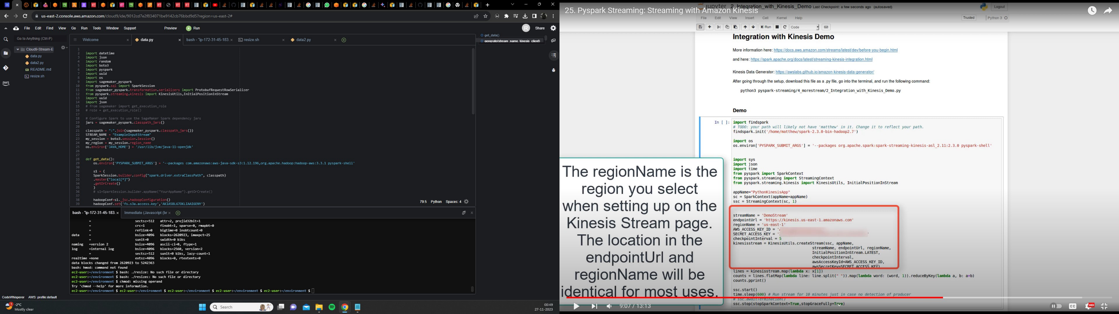

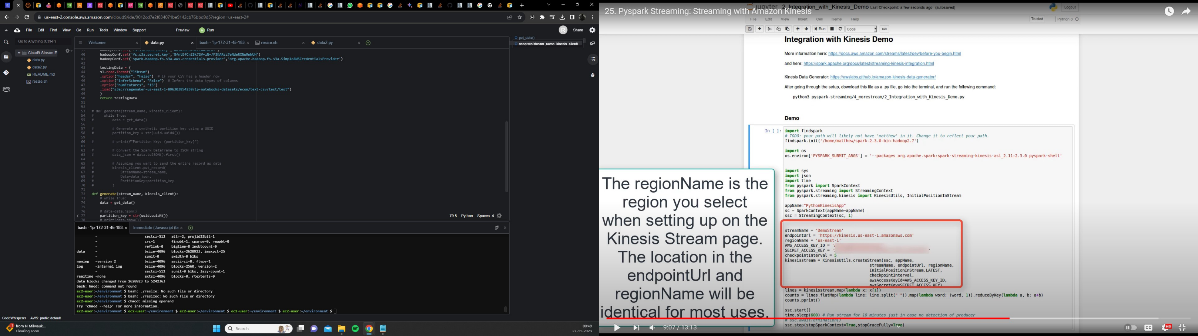

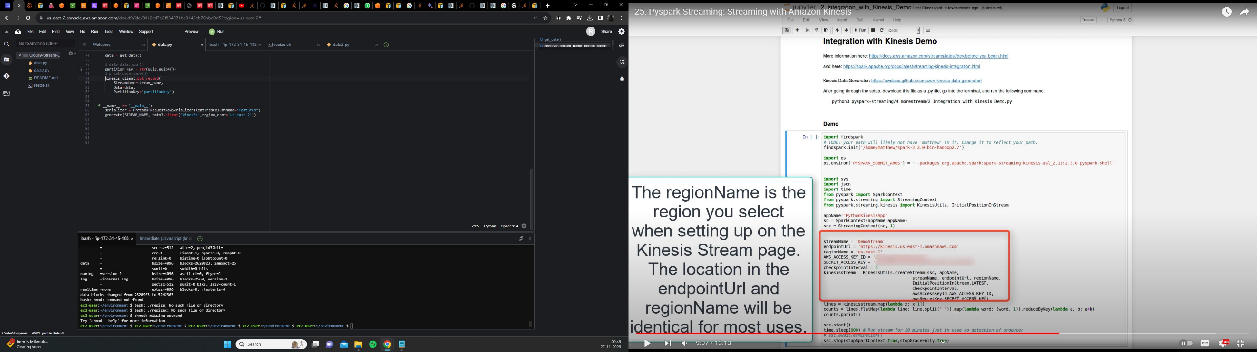

4) S3 bucket

Upload downloaded Apache Flink Java application jar file and data generator streaming python script under

sage maker studio in s3 bucket.



6) Model training

Upload the dataset to the same directory where we created a jupyter notebook in SageMaker studio.

A) Write program for training:

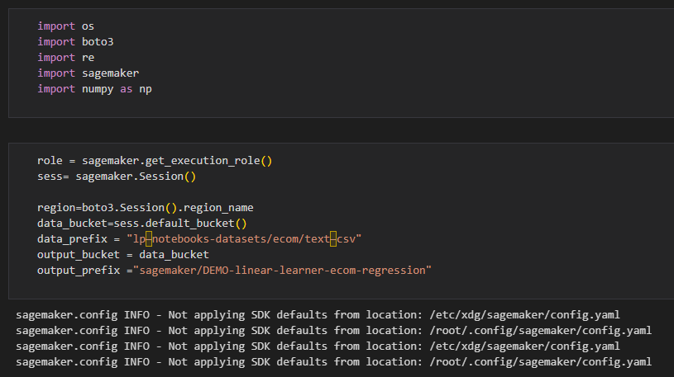

**Install Necessary JAVA libraries for PySpark:**

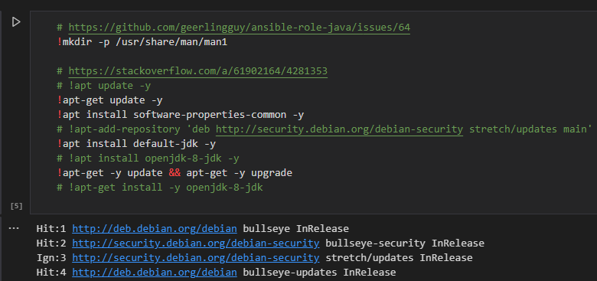

**Set JAVA_HOME:**

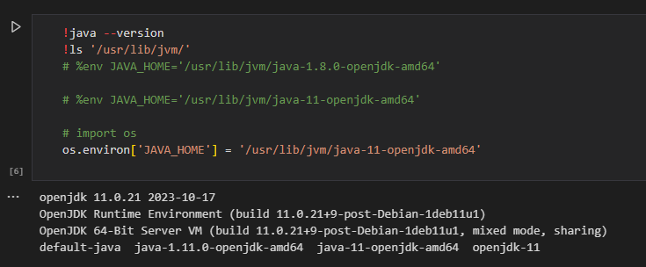

**Upload the dataset to the same directory where we created a jupyter notebook in SageMaker studio and read the file:**

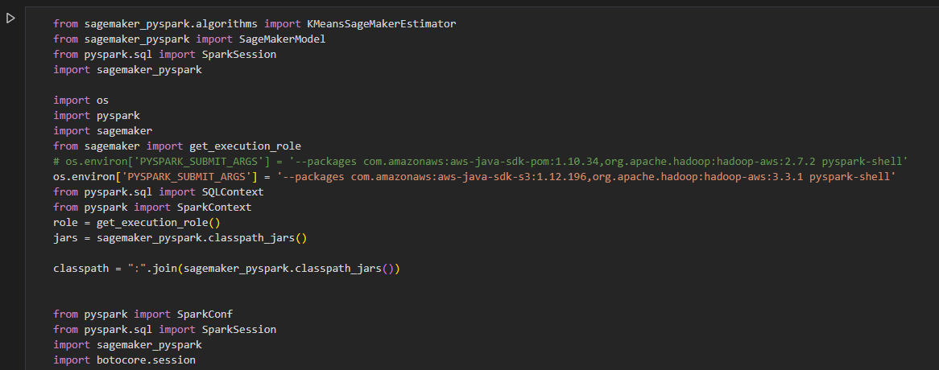

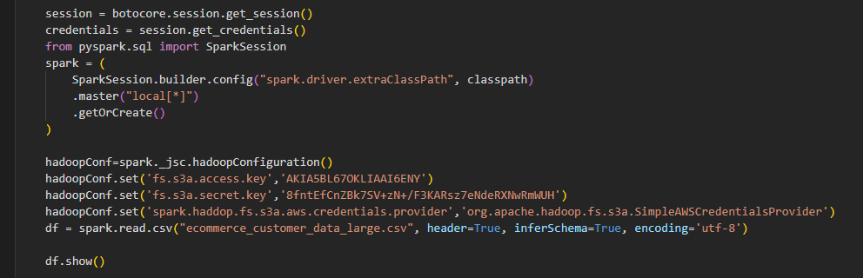

**Sample of the dataframe:**

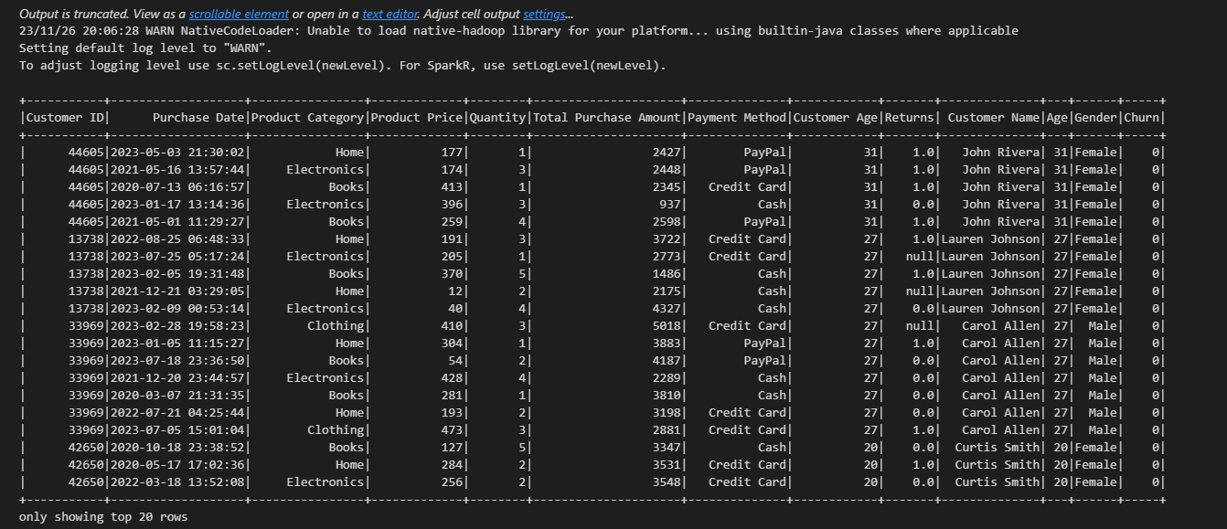

**Data Preprocessing:**

We noticed that our dataset contains feature columns like Customer ID, name, Age and Purchase Date which are irrelevant to our task. So we have decided to drop them.

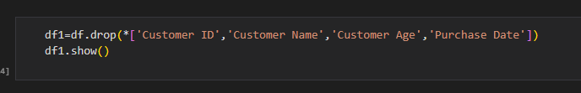

And as part of data cleaning, we made sure that there are no NaN values in the dataset before passing it to the model for training. As we can see that in Returns column there are few NaN values and we filled it with default value “0”.

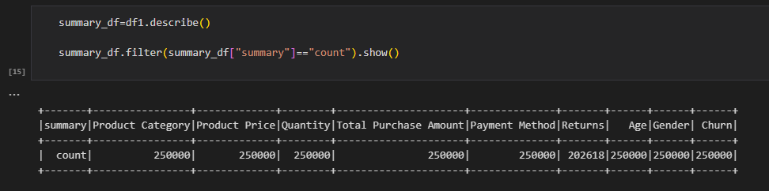

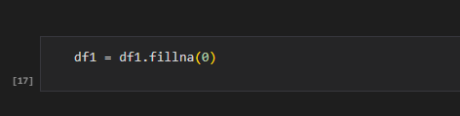

We observed that our dataset contains columns with categorical features. so we have decided to perform One-hot-encoding for these specific columns: **Product Category, Gender, Payment Method**. The reason we did this is because these columns does not contain ordinal data i.e no order preference. The following is the code to perform one-hot-encoding and after converting our dataframe contains 14 features and 1 target variable.

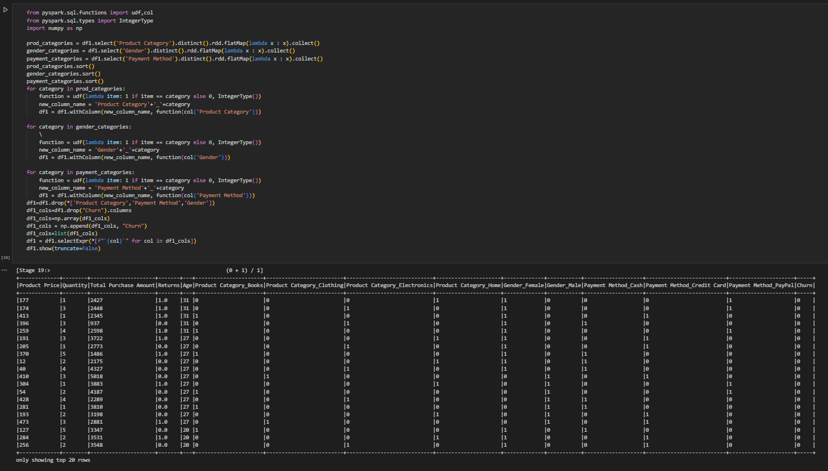

**Converting to Feature vectors:**

PySpark's VectorAssembler is used to combine selected columns from the train_data and test_data DataFrames into a single feature vector column named "features," preparing the data for machine learning model training and testing.

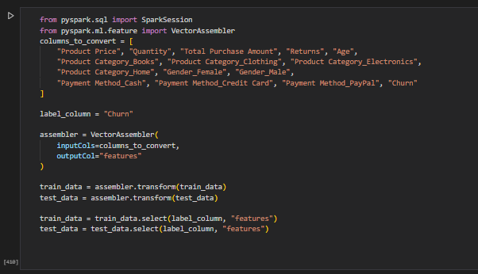

**Write to S3 bucket:**

We are saving the train_data DataFrame in the LIBSVM format, overwriting any existing data, and store it in the "train" directory in S3 bucket. LIBSVM format is commonly used for efficient representation of sparse datasets in machine learning due to its simplicity, space efficiency, and compatibility with various libraries and platforms.

We can use this data for training the model and also while prediction from Kinesis datastreams.

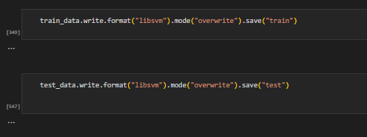

**Read Train and Test Data from S3 bucket in LIBSVM format:**

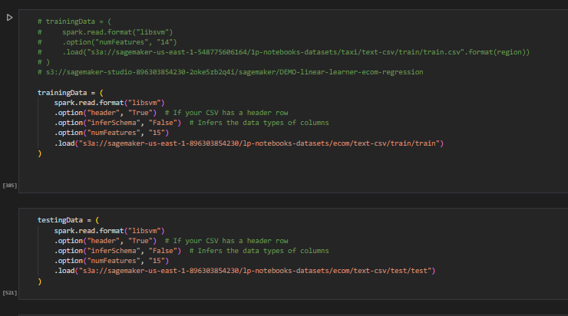

**Training Data Schema:**

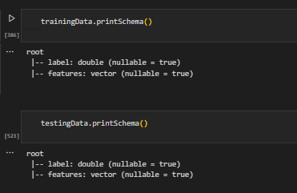

**Load Necessary Libraries for building the Model:**

We are going to use KMeansSageMakerEstimator Model.

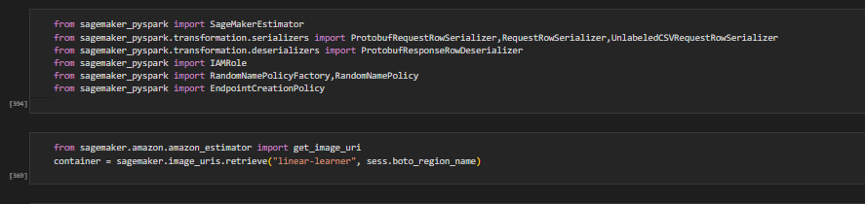

We are configuring a SageMaker KMeans estimator, setting parameters such as the SageMaker role, training and endpoint instance types, feature dimension, and the number of clusters (K) for the KMeans algorithm.

Here since we have 2 classes, we choose K=2. And no.of features = 15 including the target variable.

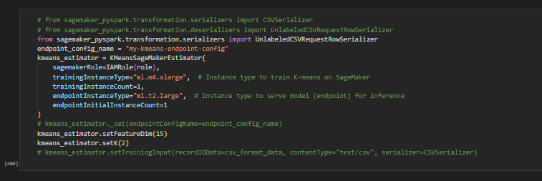

**Train the model:**

After creating the Estimator classes, the instances we requested are provisioned and configured with the necessary libraries. Then, the data is downloaded from our channels into the instance. Subsequently, the training process commences. After the training process is complete, trained model is automatically deployed on Amazon SageMaker real-time hosted endpoint. This will help to generate predictions from the model. We did not host the model on the same type of instance used for training because training is computationally expensive task that has different computation and memory requirements from hosting. Hence, we can choose a different instance type for hosting the model. We trained our model on an ml.m4.xlarge instance, but we used ml.t2.large to host the model because this instance is a less expensive cpu instance.

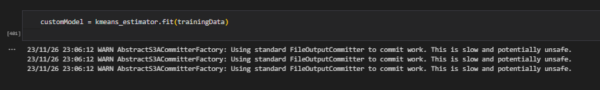

**Make prediction on our test dataset using the trained model:**

We tested our model on test data using model.transform function and the following is the output. Closest cluster column represents the predicted label 0 or 1. And label column represents Actual Label.

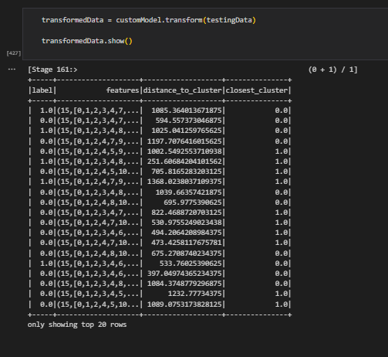

**Check the Endpoint name:**

We will use this endpoint for Kinesis Data stream.

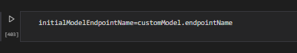

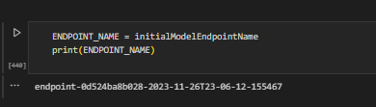

References:

1. <https://sagemaker-examples.readthedocs.io/en/latest/sagemaker-spark/pyspark_mnist/pyspark_mnist_kmeans.html>
2. <https://www.kaggle.com/datasets/shriyashjagtap/e-commerce-customer-for-behavior-analysis/>
3. <https://catalog.us-east-1.prod.workshops.aws/workshops/63069e26-921c-4ce1-9cc7-dd882ff62575/en-US/lab7>